Joanna Maślankiewicz, 222964
Marcin Łochowski, 221136

Zadanie domowe cz.1

Ubisoft (EUR, 31.01.2017 – 31.01.2025)
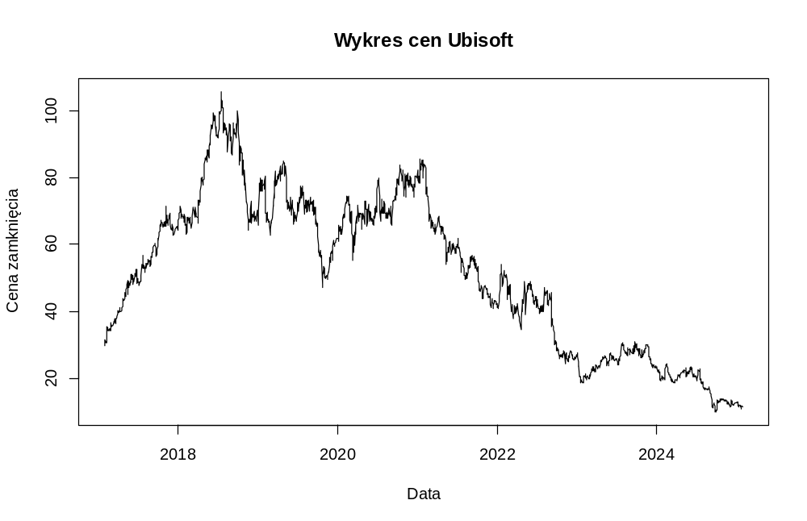
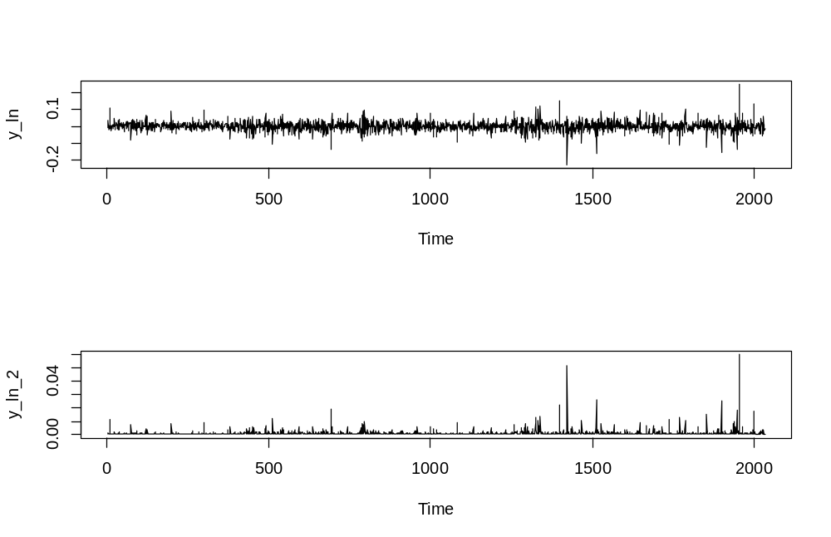
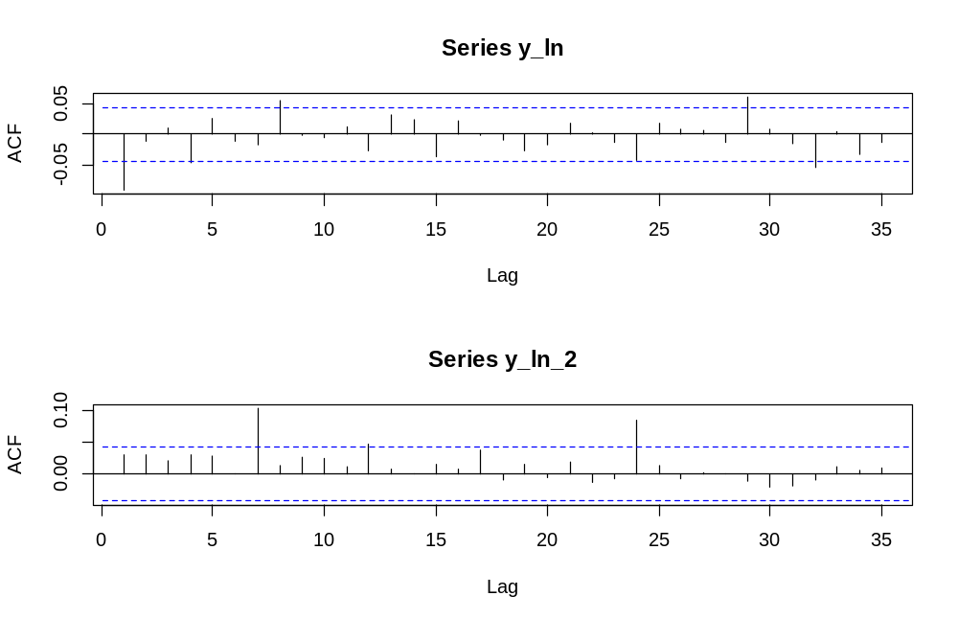
> Box.test(y_ln, lag = 20, type = "Ljung-Box")
Box-Ljung test
data: y_ln
X-squared = 42.195, df = 20, p-value = 0.002608
> Box.test(y_ln_2, lag = 20, type = "Ljung-Box")
Box-Ljung test
data: y_ln_2
X-squared = 41.814, df = 20, p-value = 0.002924

> McLeod.Li.test(y = y_ln)$p.values
[1] 1.863309e-01 1.713808e-01 2.206530e-01 1.908422e-01 1.689407e-01 2.548641e-01 9.580503e-05 1.881145e-04 2.210366e-04
[10] 2.880937e-04 5.043322e-04 1.846518e-04 3.344858e-04 5.988107e-04 8.956249e-04 1.460115e-03 9.044223e-04 1.361579e-03
[19] 1.919914e-03 2.924470e-03 3.588121e-03 4.814322e-03 6.760514e-03 1.118741e-04 1.638199e-04 2.476062e-04 3.855484e-04
[28] 5.893590e-04 8.035387e-04 9.146819e-04 1.088814e-03 1.478159e-03 1.994404e-03

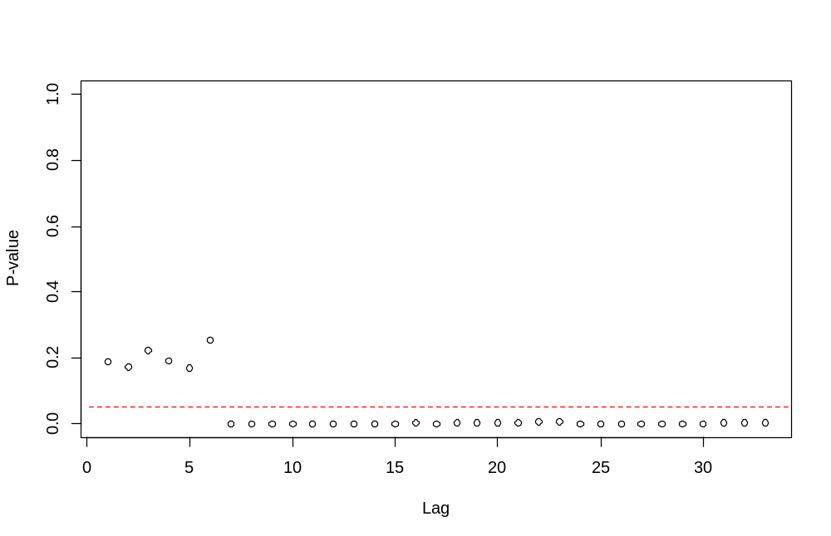
> archTest(y_ln)
Q(m) of squared series(LM test):
Test statistic: 32.85502 p-value: 0.0002880937
Rank-based Test:
Test statistic: 46.32173 p-value: 1.254005e-06

sGARCH Normal sGARCH Student GJR-GARCH
Akaike 3.327876 3.190690 3.186864
Bayes 3.341692 3.207268 3.208968
Shibata 3.327864 3.190673 3.186833
Hannan-Quinn 3.332945 3.196772 3.194973

*---------------------------------*
* GARCH Model Fit *
*---------------------------------*

Conditional Variance Dynamics
-----------------------------------
GARCH Model : gjrGARCH(1,1)
Mean Model : ARFIMA(1,0,0)
Distribution : sstd

Optimal Parameters
------------------------------------
Estimate Std. Error t value Pr(>|t|)
mu 29.974917 0.917971 32.653430 0.000000
ar1 0.998901 0.000923 1082.618042 0.000000
omega 0.000000 0.000148 0.000147 0.999883
alpha1 0.039107 0.004319 9.054131 0.000000
beta1 0.975631 0.001163 838.673915 0.000000
gamma1 -0.031003 0.007657 -4.048732 0.000051
skew 1.033059 0.027084 38.142415 0.000000
shape 4.411321 0.379923 11.611088 0.000000

Robust Standard Errors:
Estimate Std. Error t value Pr(>|t|)
mu 29.974917 0.077130 388.629562 0.000000
ar1 0.998901 0.001121 891.045594 0.000000
omega 0.000000 0.000030 0.000725 0.999422
alpha1 0.039107 0.005442 7.185634 0.000000
beta1 0.975631 0.000506 1928.873809 0.000000
gamma1 -0.031003 0.009921 -3.125022 0.001778
skew 1.033059 0.025042 41.253313 0.000000
shape 4.411321 0.332805 13.254987 0.000000

LogLikelihood : -3231.447

Information Criteria
------------------------------------

Akaike 3.1869
Bayes 3.2090
Shibata 3.1868
Hannan-Quinn 3.1950

Weighted Ljung-Box Test on Standardized Residuals
------------------------------------
statistic p-value
Lag[1] 20.28 6.681e-06
Lag[2*(p+q)+(p+q)-1][2] 20.29 0.000e+00
Lag[4*(p+q)+(p+q)-1][5] 21.86 3.032e-09
d.o.f=1
H0 : No serial correlation

Weighted Ljung-Box Test on Standardized Squared Residuals
------------------------------------
statistic p-value
Lag[1] 0.5558 0.4560
Lag[2*(p+q)+(p+q)-1][5] 0.5661 0.9470
Lag[4*(p+q)+(p+q)-1][9] 1.0216 0.9853
d.o.f=2

Weighted ARCH LM Tests
------------------------------------
Statistic Shape Scale P-Value
ARCH Lag[3] 0.002129 0.500 2.000 0.9632
ARCH Lag[5] 0.015232 1.440 1.667 0.9991
ARCH Lag[7] 0.560532 2.315 1.543 0.9726

Nyblom stability test
------------------------------------
Joint Statistic: 7.0481
Individual Statistics:
mu 1.0480
ar1 0.2309
omega 0.1811
alpha1 2.4230
beta1 2.1604
gamma1 2.0509
skew 1.0599
shape 1.9735

Asymptotic Critical Values (10% 5% 1%)
Joint Statistic: 1.89 2.11 2.59
Individual Statistic: 0.35 0.47 0.75

Sign Bias Test
------------------------------------
t-value prob sig
Sign Bias 0.4491 0.65338
Negative Sign Bias 1.8690 0.06177 *
Positive Sign Bias 0.7703 0.44122
Joint Effect 4.0894 0.25197

Adjusted Pearson Goodness-of-Fit Test:
------------------------------------
group statistic p-value(g-1)
1 20 8.879 0.9754
2 30 25.578 0.6479
3 40 30.414 0.8358
4 50 41.545 0.7663

Elapsed time : 0.8609321

Mu ar1 omega alpha1
2.997492e+01 9.989006e-01 2.171117e-08 3.910701e-02
beta1 gamma1 skew shape
9.756314e-01 -3.100274e-02 1.033059e+00 4.411321e+00

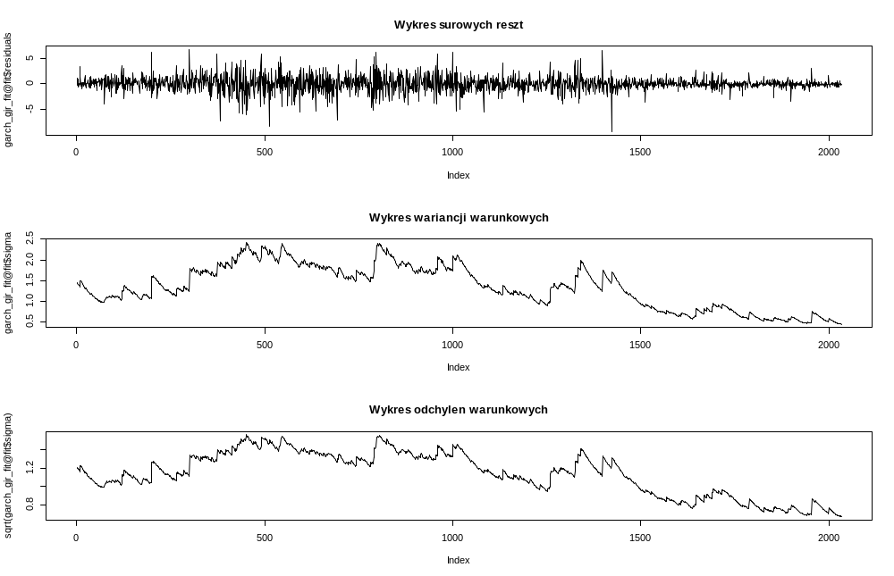
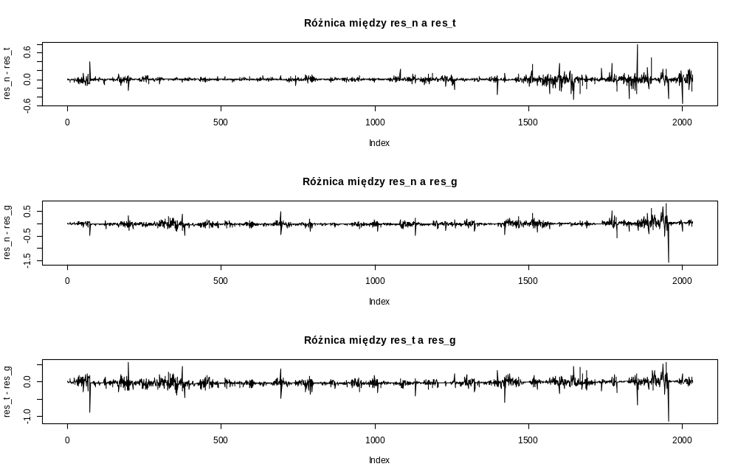

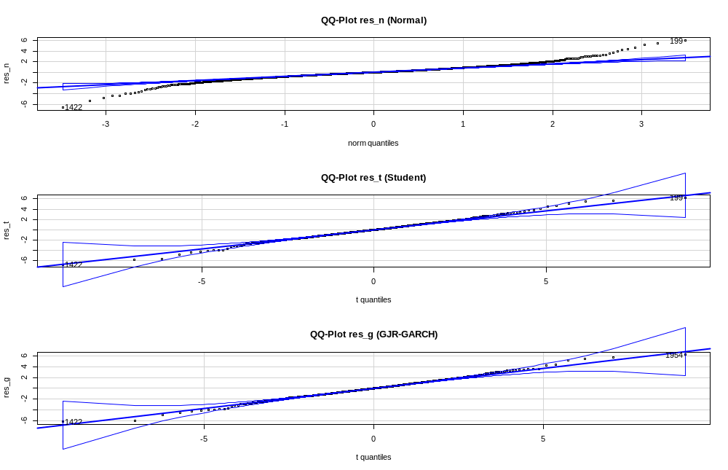
> Box.test(garch_gjr_fit@fit$residuals / garch_gjr_fit@fit$sigma, lag = 20, type = "Ljung-Box")

Box-Ljung test

data: garch_gjr_fit@fit$residuals/garch_gjr_fit@fit$sigma
X-squared = 41.734, df = 20, p-value = 0.002995

> Box.test((garch_gjr_fit@fit$residuals / garch_gjr_fit@fit$sigma)^2, lag = 20, type = "Ljung-Box")

Box-Ljung test

data: (garch_gjr_fit@fit$residuals/garch_gjr_fit@fit$sigma)^2
X-squared = 8.0887, df = 20, p-value = 0.9913

> shapiro.test(garch_gjr_fit@fit$residuals / garch_gjr_fit@fit$sigma)

Shapiro-Wilk normality test

data: garch_gjr_fit@fit$residuals/garch_gjr_fit@fit$sigma
W = 0.95447, p-value < 2.2e-16

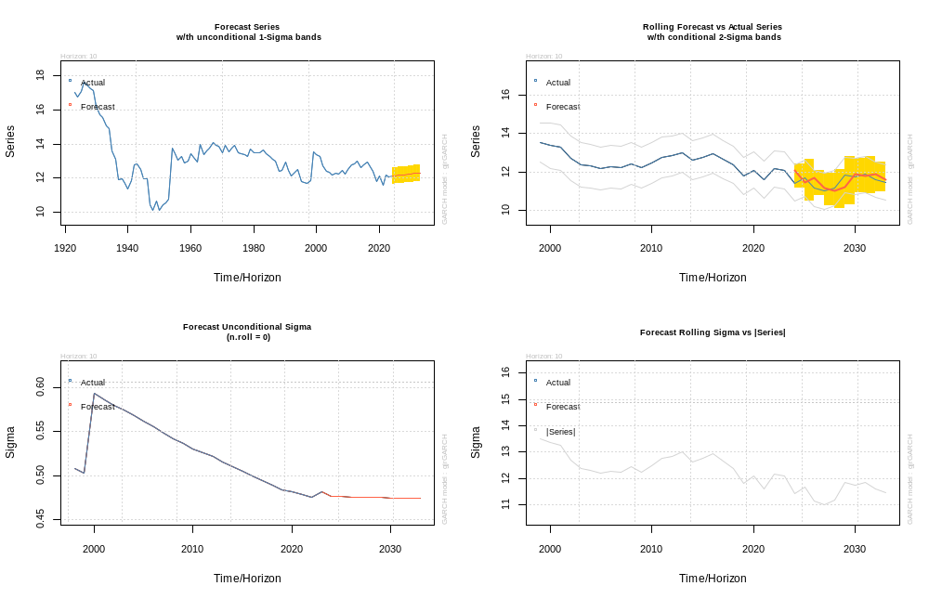

CD Projekt (PLN, 31.01.2017 – 31.01.2025)
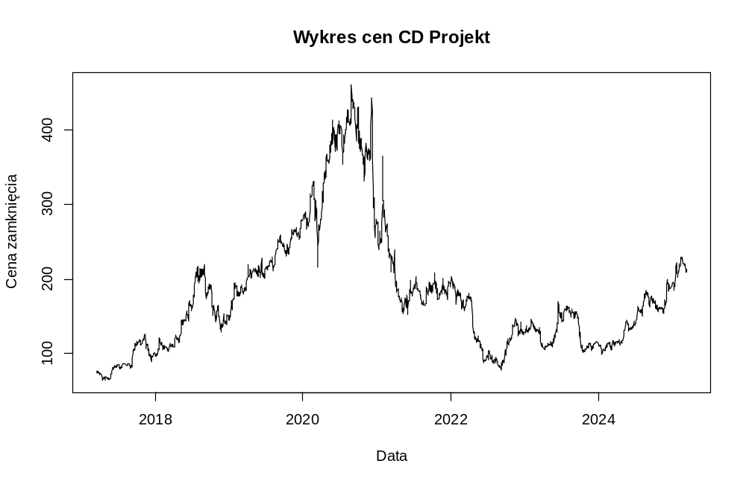
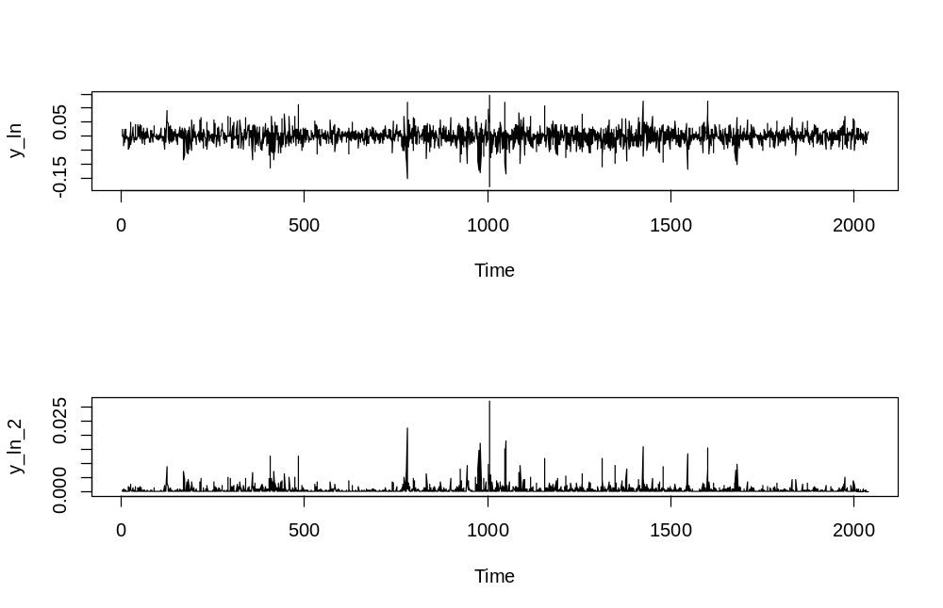

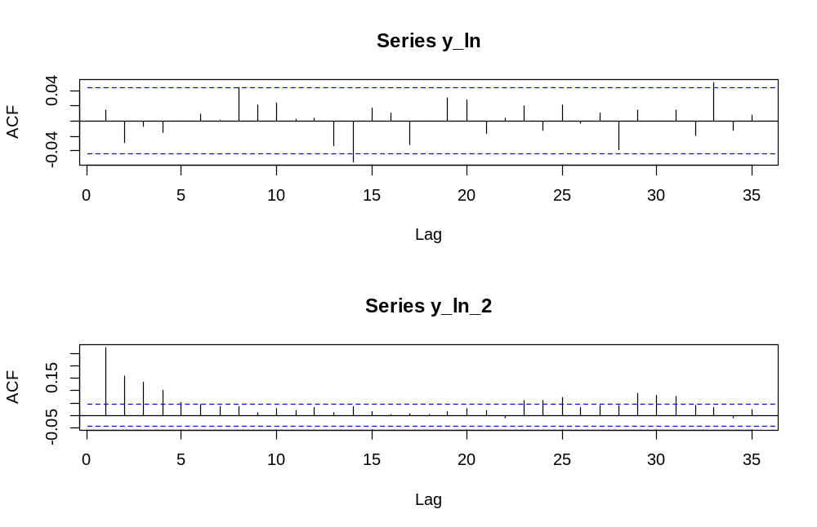

> Box.test(y_ln, lag = 20, type = "Ljung-Box")

Box-Ljung test

data: y_ln
X-squared = 23.26, df = 20, p-value = 0.2762

> Box.test(y_ln_2, lag = 20, type = "Ljung-Box")

Box-Ljung test

data: y_ln_2
X-squared = 291.5, df = 20, p-value < 2.2e-16

> McLeod.Li.test(y = y_ln)$p.values
[1] 0 0 0 0 0 0 0 0 0 0 0 0 0 0 0 0 0 0 0 0 0 0 0 0 0 0 0 0 0 0 0 0 0
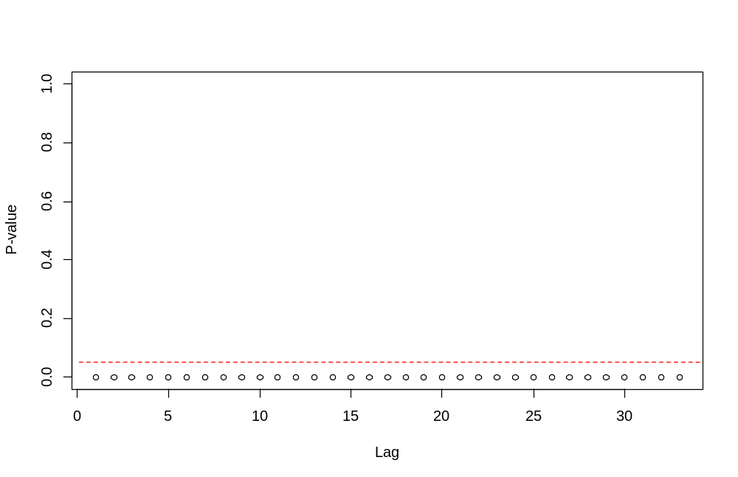
> archTest(y_ln)
Q(m) of squared series(LM test):
Test statistic: 282.7526 p-value: 0
Rank-based Test:
Test statistic: 118.9064 p-value: 0

sGARCH Normal sGARCH Student GJR-GARCH
Akaike 5.859508 5.757099 5.789351
Bayes 5.873301 5.773650 5.811419
Shibata 5.859496 5.757082 5.789320
Hannan-Quinn 5.864567 5.763171 5.797446

*---------------------------------*
* GARCH Model Fit *
*---------------------------------*

Conditional Variance Dynamics
-----------------------------------
GARCH Model : sGARCH(1,1)
Mean Model : ARFIMA(1,0,0)
Distribution : std

Optimal Parameters
------------------------------------
Estimate Std. Error t value Pr(>|t|)
mu 74.09952 3.075942 24.0900 0.000000
ar1 1.00000 0.000899 1112.1273 0.000000
omega 0.25829 0.143517 1.7997 0.071905
alpha1 0.12144 0.024638 4.9289 0.000001
beta1 0.87756 0.027575 31.8246 0.000000
shape 4.43731 0.420382 10.5554 0.000000

Robust Standard Errors:
Estimate Std. Error t value Pr(>|t|)
mu 74.09952 0.197685 374.83727 0.000000
ar1 1.00000 0.000907 1102.37511 0.000000
omega 0.25829 0.330601 0.78128 0.434640
alpha1 0.12144 0.048312 2.51358 0.011951
beta1 0.87756 0.061304 14.31488 0.000000
shape 4.43731 0.426147 10.41261 0.000000

LogLikelihood : -5857.605

Information Criteria
------------------------------------

Akaike 5.7571
Bayes 5.7737
Shibata 5.7571
Hannan-Quinn 5.7632

Weighted Ljung-Box Test on Standardized Residuals
------------------------------------
statistic p-value
Lag[1] 0.6959 0.4042
Lag[2*(p+q)+(p+q)-1][2] 1.2111 0.6094
Lag[4*(p+q)+(p+q)-1][5] 2.1442 0.6695
d.o.f=1
H0 : No serial correlation

Weighted Ljung-Box Test on Standardized Squared Residuals
------------------------------------
statistic p-value
Lag[1] 0.856 0.3549
Lag[2*(p+q)+(p+q)-1][5] 1.026 0.8537
Lag[4*(p+q)+(p+q)-1][9] 2.364 0.8574
d.o.f=2

Weighted ARCH LM Tests
------------------------------------
Statistic Shape Scale P-Value
ARCH Lag[3] 0.001308 0.500 2.000 0.9711
ARCH Lag[5] 0.461342 1.440 1.667 0.8950
ARCH Lag[7] 0.869269 2.315 1.543 0.9339

Nyblom stability test
------------------------------------
Joint Statistic: 8.7025
Individual Statistics:
mu 2.8484
ar1 0.9359
omega 1.0307
alpha1 0.8156
beta1 0.4884
shape 0.3018

Asymptotic Critical Values (10% 5% 1%)
Joint Statistic: 1.49 1.68 2.12
Individual Statistic: 0.35 0.47 0.75

Sign Bias Test
------------------------------------
t-value prob sig
Sign Bias 0.3040 0.7612
Negative Sign Bias 0.5153 0.6064
Positive Sign Bias 1.4743 0.1406
Joint Effect 3.4582 0.3262

Adjusted Pearson Goodness-of-Fit Test:
------------------------------------
group statistic p-value(g-1)
1 20 55.32 2.075e-05
2 30 87.52 8.720e-08
3 40 103.46 9.565e-08
4 50 132.39 1.337e-09

Elapsed time : 0.24931

mu ar1 omega alpha1 beta1 shape
74.0995212 1.0000000 0.2582903 0.1214373 0.8775627 4.4373056

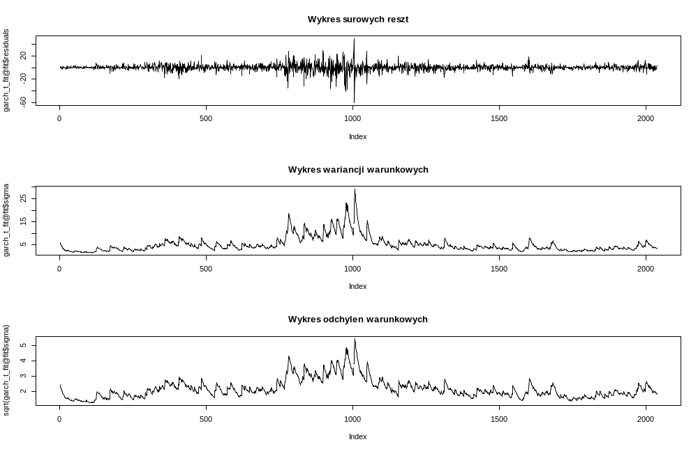

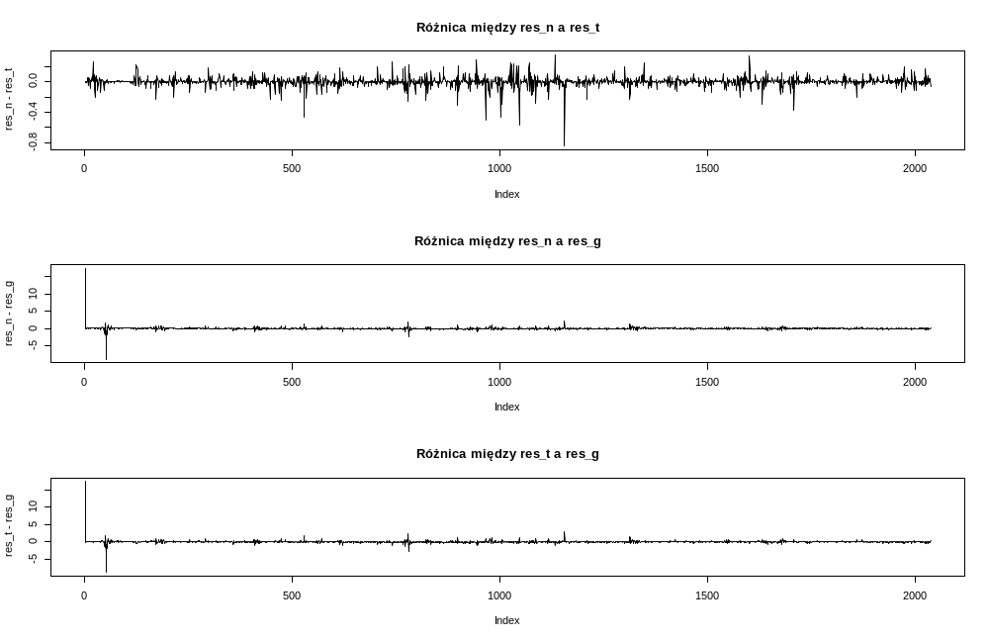

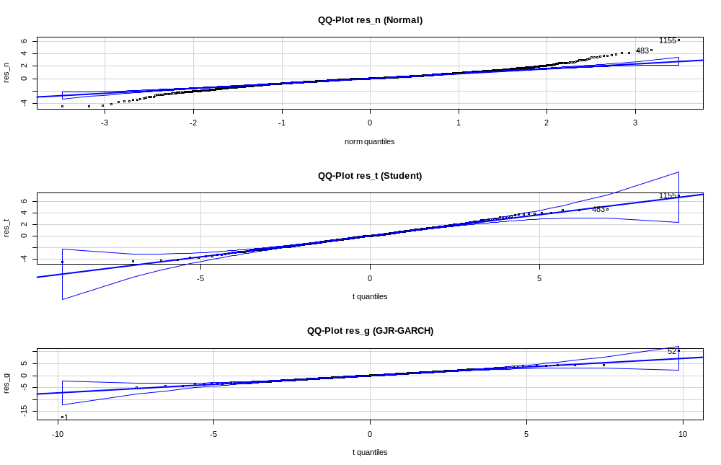

> Box.test(garch_t_fit@fit$residuals / garch_t_fit@fit$sigma, lag = 20, type = "Ljung-Box")

Box-Ljung test

data: garch_t_fit@fit$residuals/garch_t_fit@fit$sigma
X-squared = 27.468, df = 20, p-value = 0.1226

> Box.test((garch_t_fit@fit$residuals / garch_t_fit@fit$sigma)^2, lag = 20, type = "Ljung-Box")

Box-Ljung test

data: (garch_t_fit@fit$residuals/garch_t_fit@fit$sigma)^2
X-squared = 16.655, df = 20, p-value = 0.6753

> shapiro.test(garch_t_fit@fit$residuals / garch_t_fit@fit$sigma)

Shapiro-Wilk normality test

data: garch_t_fit@fit$residuals/garch_t_fit@fit$sigma
W = 0.96556, p-value < 2.2e-16

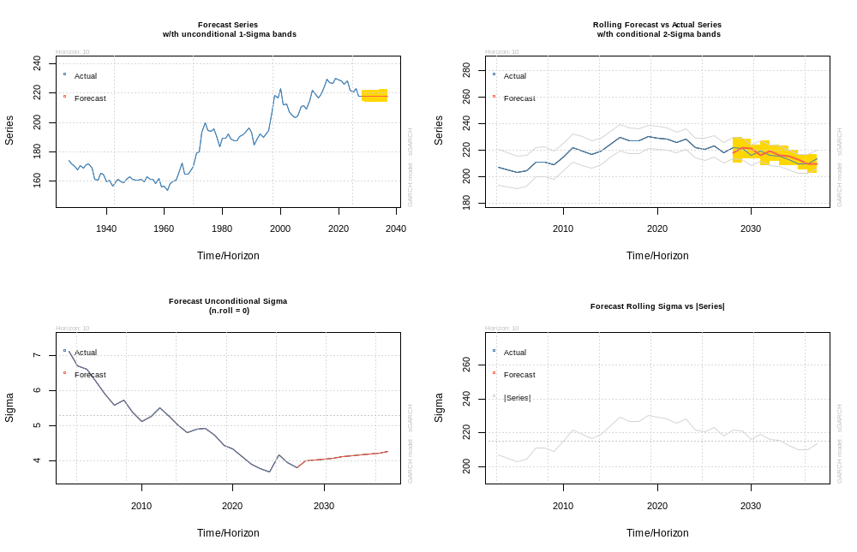

EA (USD, 31.01.2017 – 31.01.2025)

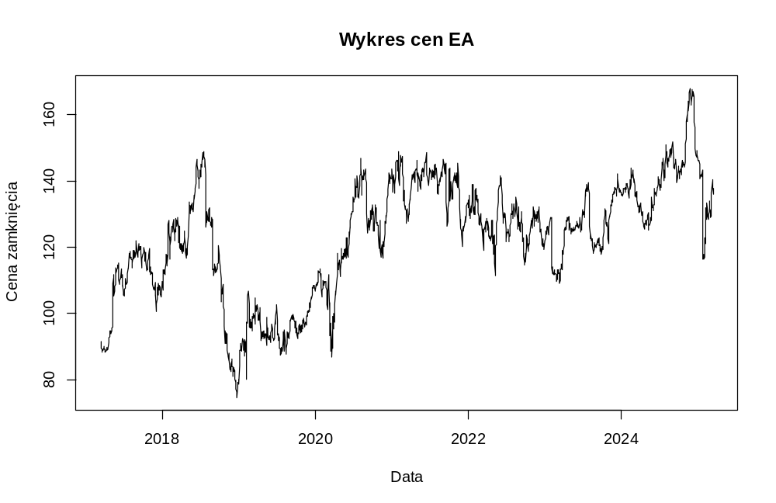

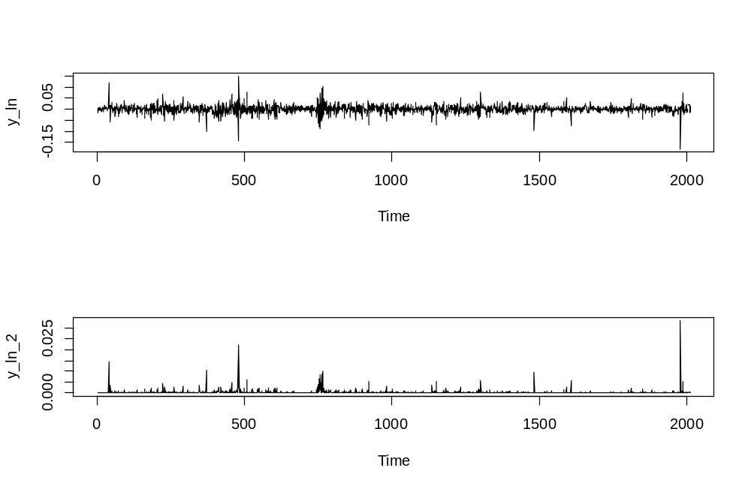

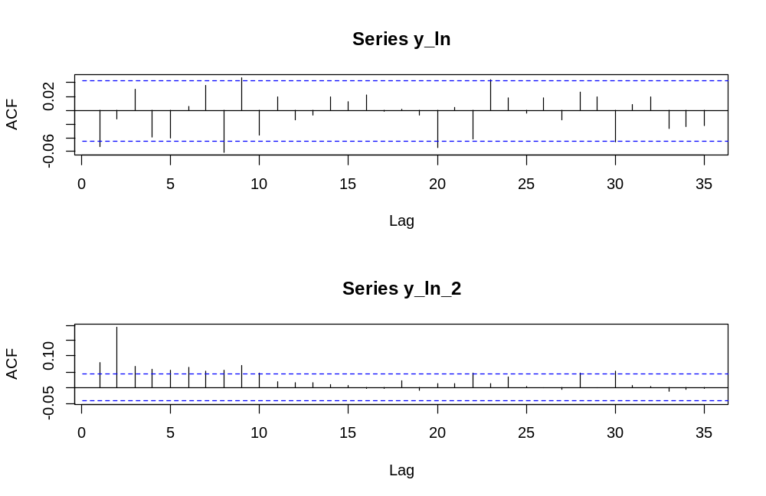

> Box.test(y_ln, lag = 20, type = "Ljung-Box")

Box-Ljung test

data: y_ln
X-squared = 40.56, df = 20, p-value = 0.004241

> Box.test(y_ln_2, lag = 20, type = "Ljung-Box")

Box-Ljung test

data: y_ln_2
X-squared = 149.64, df = 20, p-value < 2.2e-16

> McLeod.Li.test(y = y_ln)$p.values
[1] 0.0002551196 0.0000000000 0.0000000000 0.0000000000 0.0000000000 0.0000000000 0.0000000000 0.0000000000 0.0000000000
[10] 0.0000000000 0.0000000000 0.0000000000 0.0000000000 0.0000000000 0.0000000000 0.0000000000 0.0000000000 0.0000000000
[19] 0.0000000000 0.0000000000 0.0000000000 0.0000000000 0.0000000000 0.0000000000 0.0000000000 0.0000000000 0.0000000000
[28] 0.0000000000 0.0000000000 0.0000000000 0.0000000000 0.0000000000 0.0000000000

> archTest(y_ln)
Q(m) of squared series(LM test):
Test statistic: 146.1599 p-value: 0
Rank-based Test:
Test statistic: 201.7781 p-value: 0

sGARCH Normal sGARCH Student GJR-GARCH
Akaike 4.321915 4.116581 4.113414
Bayes 4.338635 4.136088 4.138495
Shibata 4.321897 4.116557 4.113374
Hannan-Quinn 4.328052 4.123741 4.122620

*---------------------------------*
* GARCH Model Fit *
*---------------------------------*

Conditional Variance Dynamics
-----------------------------------
GARCH Model : gjrGARCH(1,1)
Mean Model : ARFIMA(1,d,0)
Distribution : sstd

Optimal Parameters
------------------------------------
Estimate Std. Error t value Pr(>|t|)
mu 90.67849 1.260921 71.914473 0.000000
ar1 1.00000 0.001163 860.036017 0.000000
arfima 0.00000 0.018715 0.000005 0.999996
omega 0.52330 0.195312 2.679311 0.007377
alpha1 0.11327 0.037720 3.003001 0.002673
beta1 0.76382 0.064704 11.804796 0.000000
gamma1 0.03493 0.048948 0.713620 0.475462
skew 0.91454 0.028156 32.480938 0.000000
shape 4.16941 0.389998 10.690851 0.000000

Robust Standard Errors:
Estimate Std. Error t value Pr(>|t|)
mu 90.67849 0.074454 1.2179e+03 0.000000
ar1 1.00000 0.001208 8.2791e+02 0.000000
arfima 0.00000 0.018910 5.0000e-06 0.999996
omega 0.52330 0.317313 1.6492e+00 0.099114
alpha1 0.11327 0.043232 2.6201e+00 0.008790
beta1 0.76382 0.101612 7.5171e+00 0.000000
gamma1 0.03493 0.062747 5.5668e-01 0.577745
skew 0.91454 0.027144 3.3692e+01 0.000000
shape 4.16941 0.483180 8.6291e+00 0.000000

LogLikelihood : -4129.095

Information Criteria
------------------------------------

Akaike 4.1134
Bayes 4.1385
Shibata 4.1134
Hannan-Quinn 4.1226

Weighted Ljung-Box Test on Standardized Residuals
------------------------------------
statistic p-value
Lag[1] 0.02636 0.8710
Lag[2*(p+q)+(p+q)-1][2] 0.13703 0.9997
Lag[4*(p+q)+(p+q)-1][5] 1.26312 0.9000
d.o.f=1
H0 : No serial correlation

Weighted Ljung-Box Test on Standardized Squared Residuals
------------------------------------
statistic p-value
Lag[1] 0.2962 0.5863
Lag[2*(p+q)+(p+q)-1][5] 0.6378 0.9345
Lag[4*(p+q)+(p+q)-1][9] 0.9926 0.9866
d.o.f=2

Weighted ARCH LM Tests
------------------------------------
Statistic Shape Scale P-Value
ARCH Lag[3] 0.2746 0.500 2.000 0.6003
ARCH Lag[5] 0.5169 1.440 1.667 0.8786
ARCH Lag[7] 0.7743 2.315 1.543 0.9473

Nyblom stability test
------------------------------------
Joint Statistic: 2.81
Individual Statistics:
mu 0.001356
ar1 0.079291
arfima 0.992433
omega 0.622826
alpha1 0.752316
beta1 0.630677
gamma1 1.033320
skew 0.063408
shape 0.848275

Asymptotic Critical Values (10% 5% 1%)
Joint Statistic: 2.1 2.32 2.82
Individual Statistic: 0.35 0.47 0.75

Sign Bias Test
------------------------------------
t-value prob sig
Sign Bias 0.6005 0.5482
Negative Sign Bias 0.7930 0.4279
Positive Sign Bias 0.3220 0.7475
Joint Effect 1.0612 0.7864

Adjusted Pearson Goodness-of-Fit Test:
------------------------------------
group statistic p-value(g-1)
1 20 19.87 0.40251
2 30 36.14 0.16949
3 40 58.34 0.02391
4 50 51.27 0.38474

Elapsed time : 5.99345

Mu ar1 arfima omega
9.067849e+01 1.000000e+00 1.017648e-07 5.233003e-01
alpha1 beta1 gamma1 skew
1.132729e-01 7.638233e-01 3.493006e-02 9.145402e-01
shape
4.169413e+00

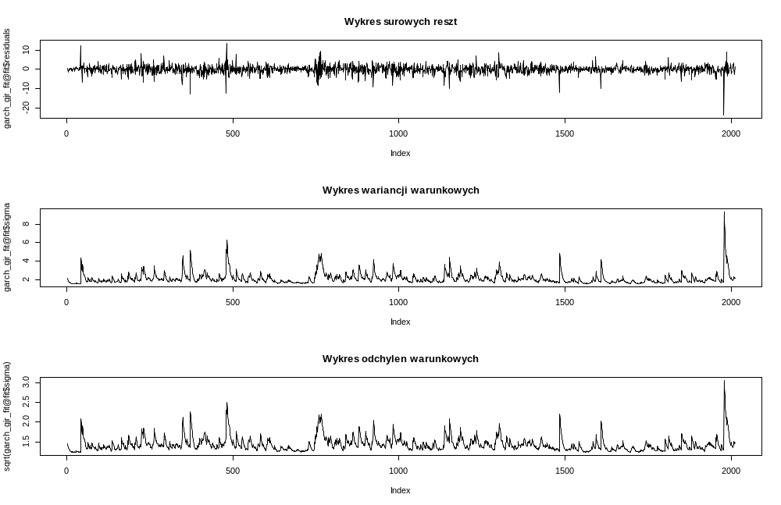
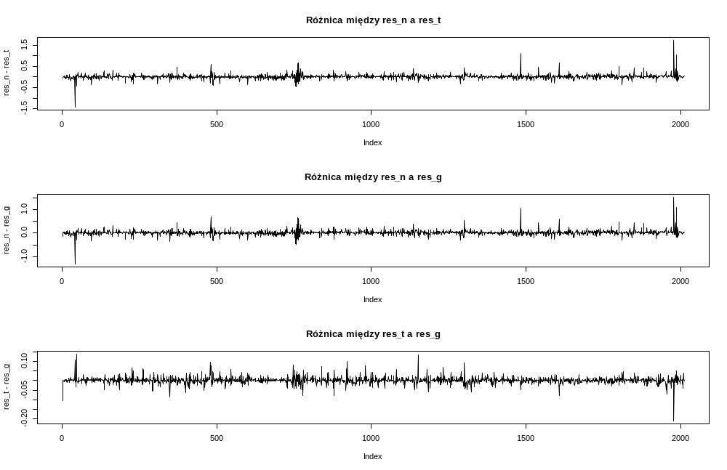

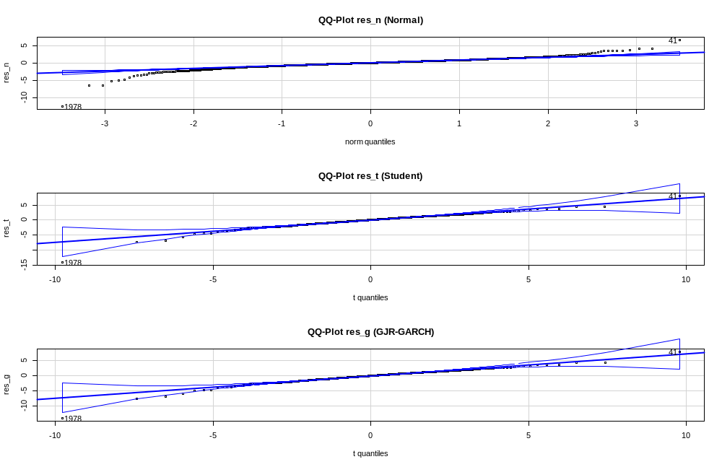

> Box.test(garch_gjr_fit@fit$residuals / garch_gjr_fit@fit$sigma, lag = 20, type = "Ljung-Box")

Box-Ljung test

data: garch_gjr_fit@fit$residuals/garch_gjr_fit@fit$sigma
X-squared = 17.117, df = 20, p-value = 0.6453

> Box.test((garch_gjr_fit@fit$residuals / garch_gjr_fit@fit$sigma)^2, lag = 20, type = "Ljung-Box")

Box-Ljung test

data: (garch_gjr_fit@fit$residuals/garch_gjr_fit@fit$sigma)^2
X-squared = 3.1295, df = 20, p-value = 1

> shapiro.test(garch_gjr_fit@fit$residuals / garch_gjr_fit@fit$sigma)

Shapiro-Wilk normality test

data: garch_gjr_fit@fit$residuals/garch_gjr_fit@fit$sigma
W = 0.89423, p-value < 2.2e-16

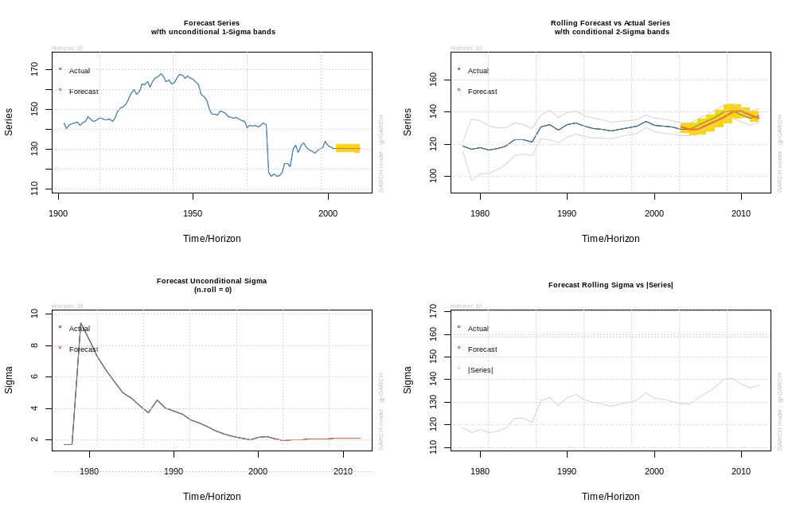

Sega (JPY, 31.01.2017 – 31.01.2025)

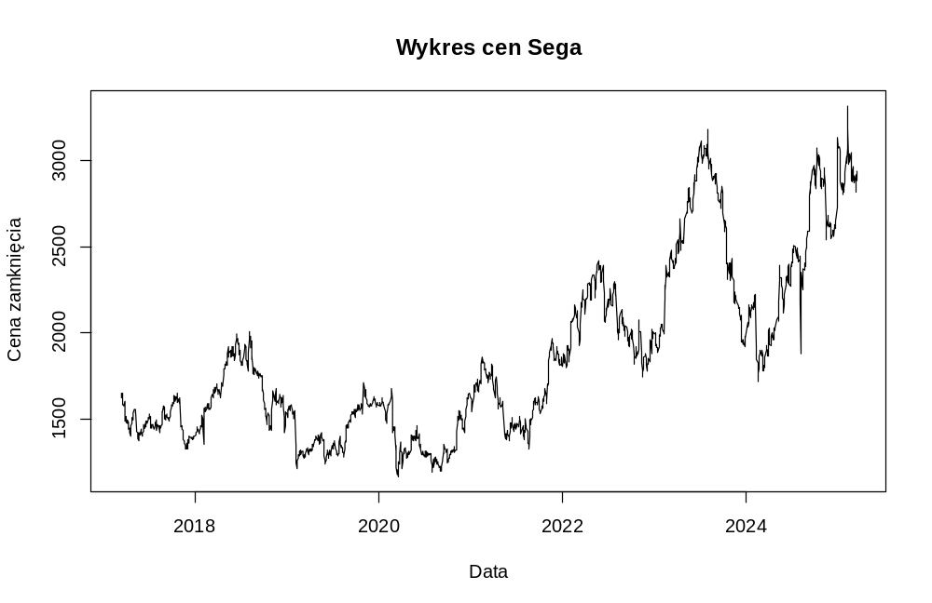
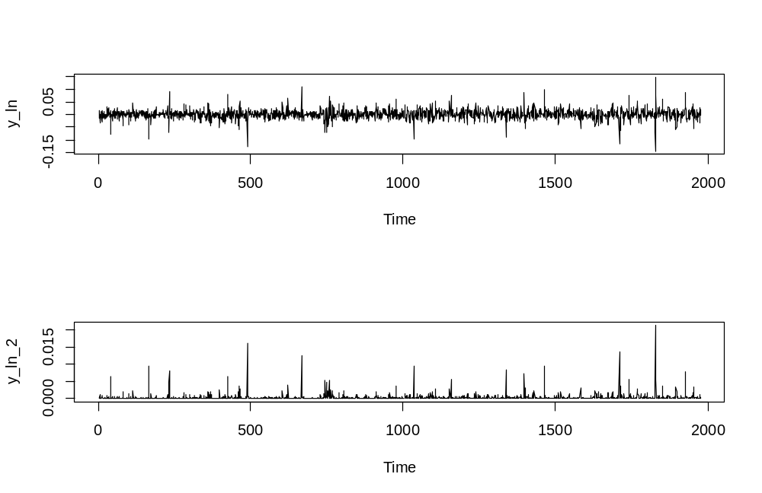
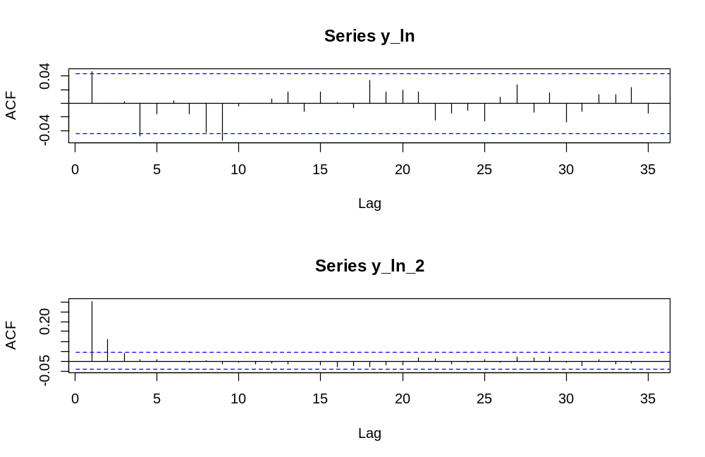
> Box.test(y_ln, lag = 20, type = "Ljung-Box")

Box-Ljung test

data: y_ln
X-squared = 24.269, df = 20, p-value = 0.2309

> Box.test(y_ln_2, lag = 20, type = "Ljung-Box")

Box-Ljung test

data: y_ln_2
X-squared = 222.63, df = 20, p-value < 2.2e-16

> McLeod.Li.test(y = y_ln)$p.values
[1] 0 0 0 0 0 0 0 0 0 0 0 0 0 0 0 0 0 0 0 0 0 0 0 0 0 0 0 0 0 0 0 0

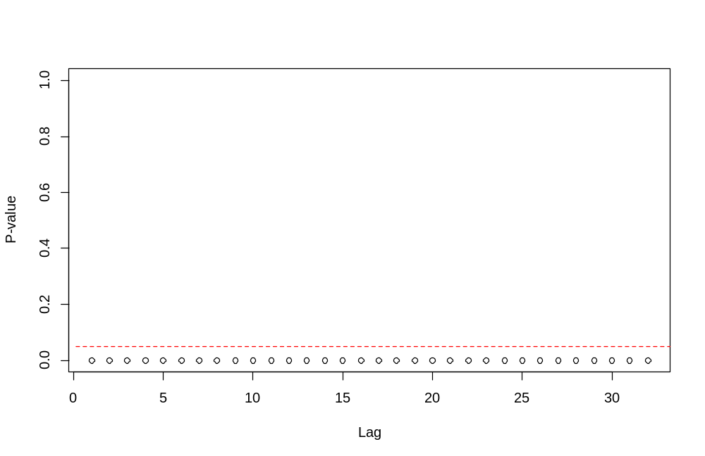

> archTest(y_ln)
Q(m) of squared series(LM test):
Test statistic: 214.9868 p-value: 0
Rank-based Test:
Test statistic: 61.08795 p-value: 2.25476e-09

sGARCH Normal sGARCH Student GJR-GARCH
Akaike 9.942836 9.716439 9.723799
Bayes 9.959807 9.736238 9.749254
Shibata 9.942818 9.716414 9.723757
Hannan-Quinn 9.949071 9.723714 9.733151

*---------------------------------*
* GARCH Model Fit *
*---------------------------------*

Conditional Variance Dynamics
-----------------------------------
GARCH Model : sGARCH(1,1)
Mean Model : ARFIMA(1,d,0)
Distribution : std

Optimal Parameters
------------------------------------
Estimate Std. Error t value Pr(>|t|)
mu 1652.93968 21.817377 75.762529 0.000000
ar1 0.99790 0.001573 634.227104 0.000000
arfima 0.00000 0.018570 0.000001 1.000000
omega 109.00317 32.732926 3.330077 0.000868
alpha1 0.19134 0.039780 4.809955 0.000002
beta1 0.75932 0.044960 16.888966 0.000000
shape 3.66019 0.310351 11.793727 0.000000

Robust Standard Errors:
Estimate Std. Error t value Pr(>|t|)
mu 1652.93968 2.958347 558.737607 0.000000
ar1 0.99790 0.001580 631.648482 0.000000
arfima 0.00000 0.017317 0.000001 1.000000
omega 109.00317 50.608552 2.153849 0.031252
alpha1 0.19134 0.054172 3.532073 0.000412
beta1 0.75932 0.068354 11.108638 0.000000
shape 3.66019 0.312230 11.722729 0.000000

LogLikelihood : -9592.842

Information Criteria
------------------------------------

Akaike 9.7164
Bayes 9.7362
Shibata 9.7164
Hannan-Quinn 9.7237

Weighted Ljung-Box Test on Standardized Residuals
------------------------------------
statistic p-value
Lag[1] 2.489 0.11463
Lag[2*(p+q)+(p+q)-1][2] 2.862 0.04613
Lag[4*(p+q)+(p+q)-1][5] 4.099 0.21016
d.o.f=1
H0 : No serial correlation

Weighted Ljung-Box Test on Standardized Squared Residuals
------------------------------------
statistic p-value
Lag[1] 0.000029 0.9957
Lag[2*(p+q)+(p+q)-1][5] 1.036893 0.8513
Lag[4*(p+q)+(p+q)-1][9] 2.138321 0.8879
d.o.f=2

Weighted ARCH LM Tests
------------------------------------
Statistic Shape Scale P-Value
ARCH Lag[3] 0.6748 0.500 2.000 0.4114
ARCH Lag[5] 1.3181 1.440 1.667 0.6414
ARCH Lag[7] 2.0576 2.315 1.543 0.7051

Nyblom stability test
------------------------------------
Joint Statistic: 4.3251
Individual Statistics:
mu 0.2188
ar1 0.1572
arfima 0.1091
omega 3.2527
alpha1 2.9060
beta1 3.2934
shape 2.7097

Asymptotic Critical Values (10% 5% 1%)
Joint Statistic: 1.69 1.9 2.35
Individual Statistic: 0.35 0.47 0.75

Sign Bias Test
------------------------------------
t-value prob sig
Sign Bias 0.68663 0.4924
Negative Sign Bias 0.30353 0.7615
Positive Sign Bias 0.08934 0.9288
Joint Effect 1.49217 0.6841

Adjusted Pearson Goodness-of-Fit Test:
------------------------------------
group statistic p-value(g-1)
1 20 32.14 0.030157
2 30 48.97 0.011634
3 40 65.82 0.004611
4 50 82.20 0.002078

Elapsed time : 4.533163

Mu ar1 arfima omega
1.652940e+03 9.979039e-01 1.060219e-08 1.090032e+02
alpha1 beta1 shape
1.913378e-01 7.593209e-01 3.660190e+00

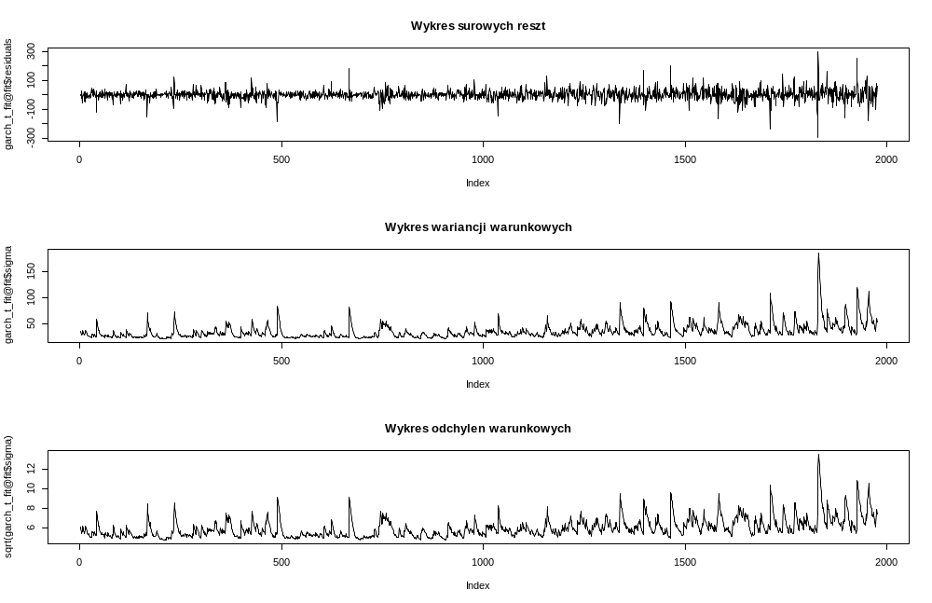
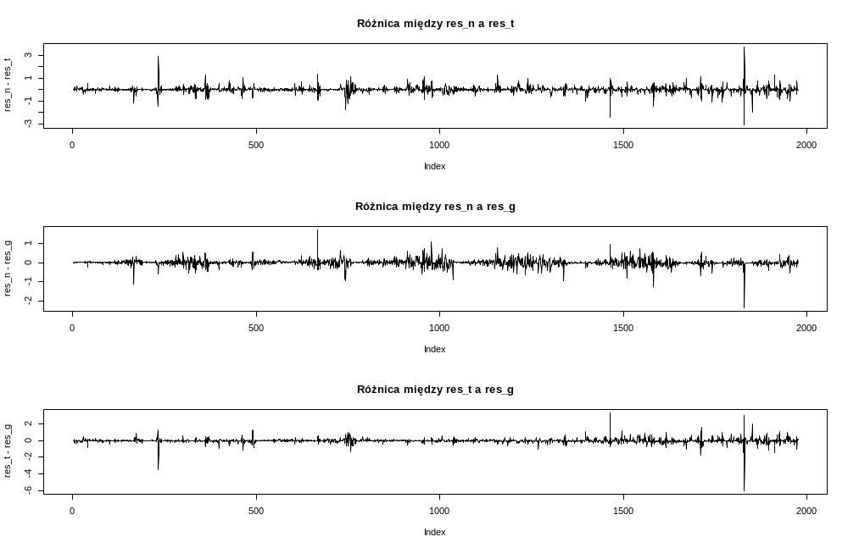
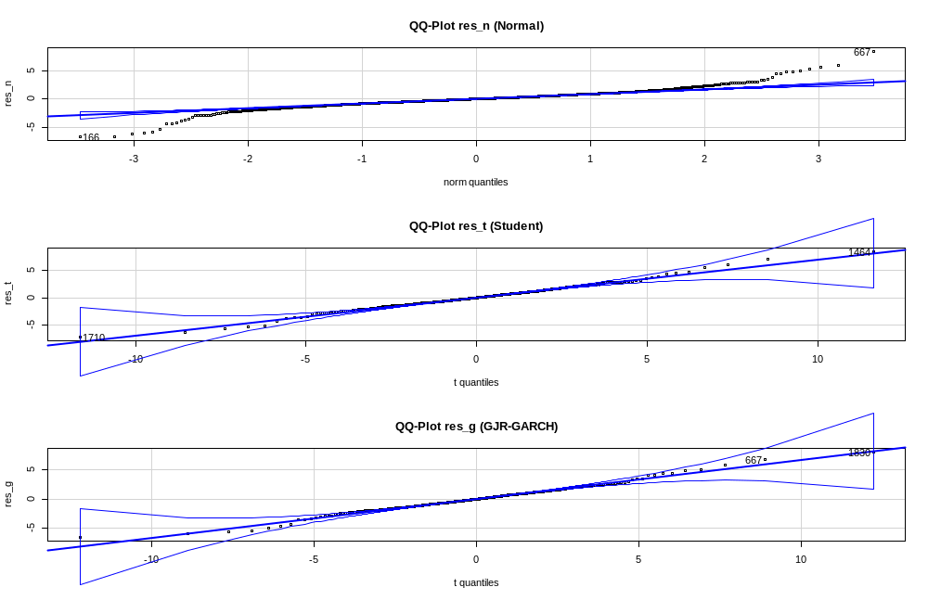
> Box.test(garch_t_fit@fit$residuals / garch_t_fit@fit$sigma, lag = 20, type = "Ljung-Box")

Box-Ljung test

data: garch_t_fit@fit$residuals/garch_t_fit@fit$sigma
X-squared = 20.047, df = 20, p-value = 0.455

> Box.test((garch_t_fit@fit$residuals / garch_t_fit@fit$sigma)^2, lag = 20, type = "Ljung-Box")

Box-Ljung test

data: (garch_t_fit@fit$residuals/garch_t_fit@fit$sigma)^2
X-squared = 9.106, df = 20, p-value = 0.9816

> shapiro.test(garch_t_fit@fit$residuals / garch_t_fit@fit$sigma)

Shapiro-Wilk normality test

data: garch_t_fit@fit$residuals/garch_t_fit@fit$sigma
W = 0.91667, p-value < 2.2e-16

